Agile Methodology
Local Community Skill Exchange and Help Board
Group F | Md Abdullah Maz | Fahad Ahmed

Introduction
This project adopts the Agile methodology and is divided into two sprints. Each sprint delivers a functional increment of the system while incorporating continuous feedback and improvement.

Sprint 1: Core Platform Development (Week 1-4)
Objective | Develop the essential platform features.
Tasks | Requirements gathering, database design, user registration/login, profile management, create and browse listings, nearby search.
Deliverables | Authentication module, user profiles, help board, search interface.
Outcome | Users can successfully register and exchange help requests.

Sprint 2: Communication and Deployment (Week 5-8)
Objective | Enhance collaboration and prepare for production.
Tasks | Real-time chat, ratings, reviews, report/block user, admin panel, testing and deployment.
Deliverables | Messaging system, review module, moderation tools, deployed prototype.
Outcome | A secure and fully functional community platform.

Agile Workflow Diagram
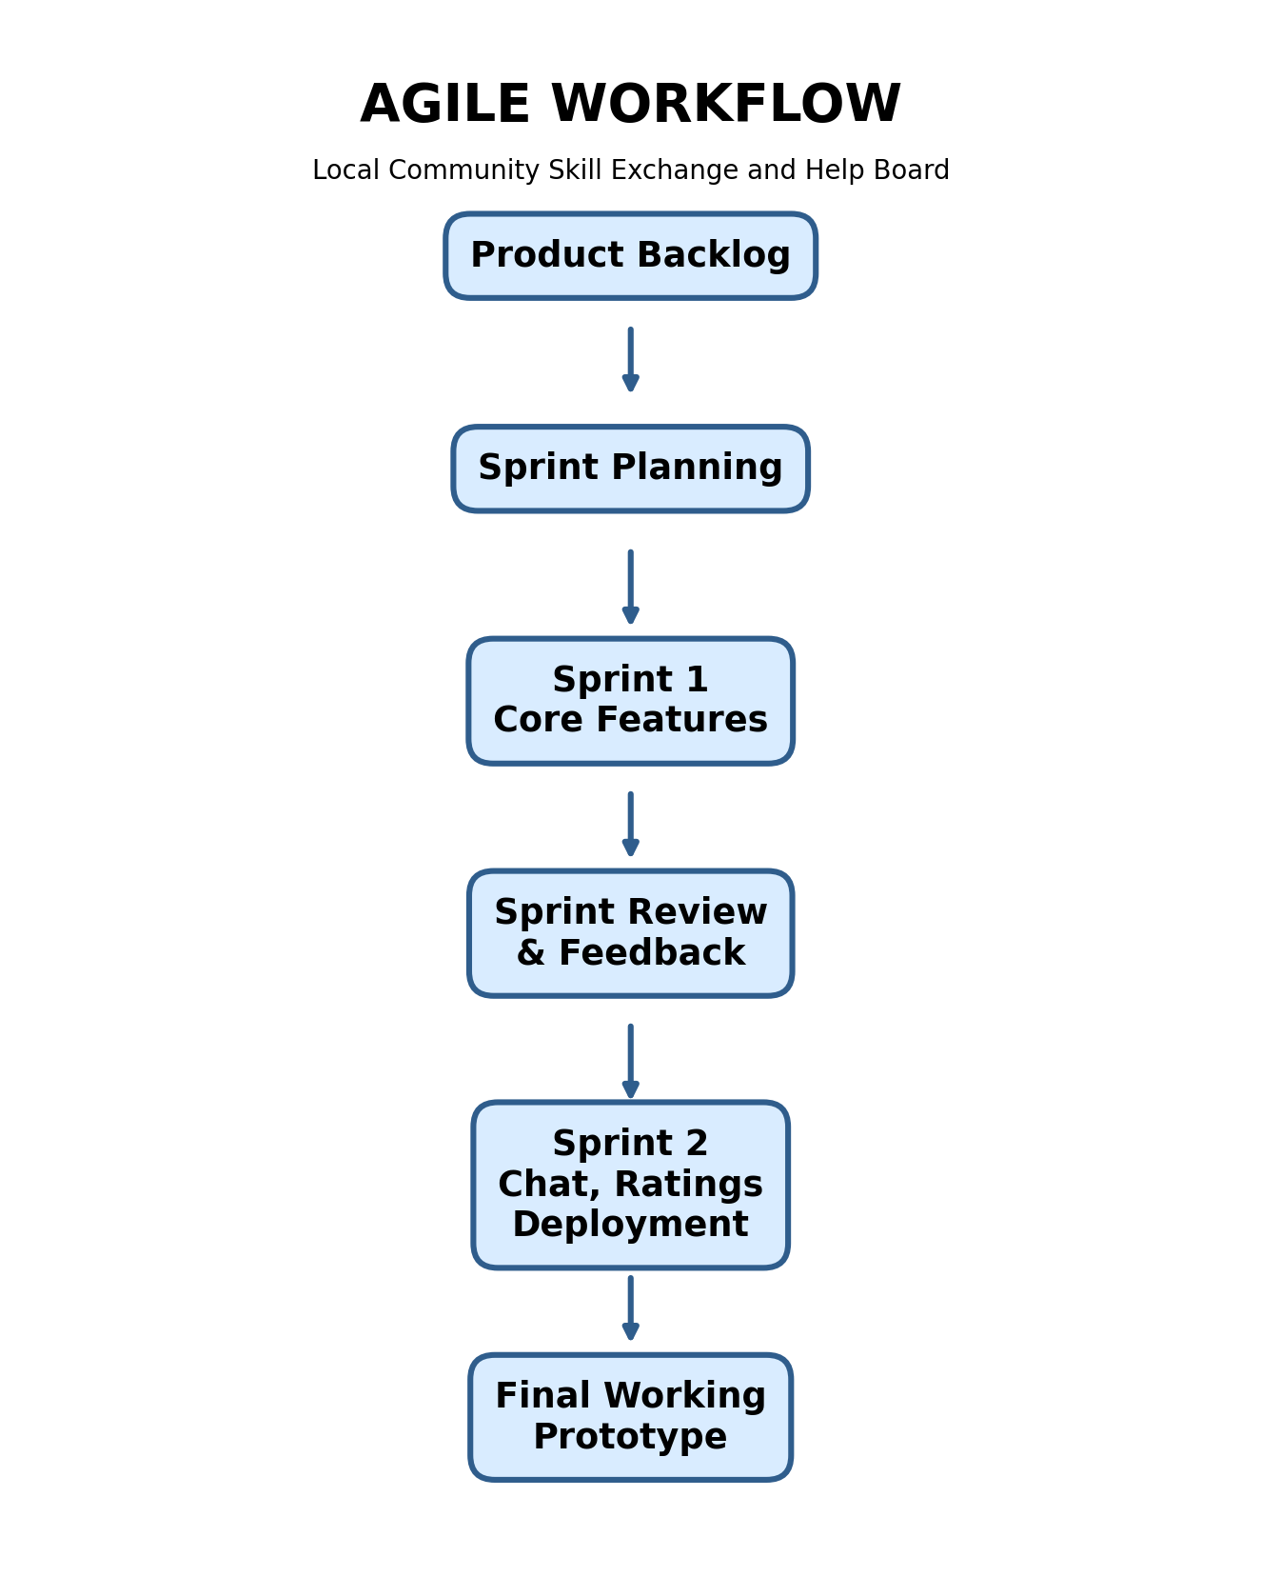
Figure 1: Agile Workflow with Two Sprints

